# IGME 480 Final Project Proposal: Augmented Reality Tower Defense

Team Members

Juri Kiin

Kegan Sovay

Sam Levey

Bennett Schoonerman

Zoe Kniskern

Technology Stack

Mobile Augmented Reality - Vuforia

* Image Targets

Unity

Git Source Control

Abstract

Base defense game where the user places cards on their table to layout pieces like walls, turrets, archers, etc. When they’re done moving a piece, tap on the object, and then it gets attached to the

A science fiction themed tower defense game where defensive structures in the game world correspond to real world image target cards. Players are challenged to fend off drone invasions by choosing strategic arrangements of walls and turrets with their cards before watching to see how their plan works out in a rendered battle. Battle victories reward players with opportunities to increase the strength or damage potential of their structures before the next battle!

This game, meant for the player to be somewhat statically positioned, combines familiar elements of card placement and physical deck ownership with beautiful and immersive augmented reality graphics.

# Project Scope

Game Flow

* Opening screen
  + Camera view
  + UI Button: “Cards Set”
  + UI Text: “Place cards on a flat surface.. Arrange for defense.. Select button to start”
* Users can place cards in physical space - centered around “Master Game Card” which holds the entire scene.
  + Models for each card will be visible when the user moves the cards around.
* Once all cards are placed, user presses “Start/Cards Set” Button
* Locations of each card is recorded in reference to Master Game Card and models are instantiated in the Master Game Card Scene
* Once set, enemies begin attack and models will fire back.
  + Timer?
  + Number of enemy
  + Battle lasts as long as enemies are still alive
* Once timer is up and/or all enemies are gone, damage is assessed and UI text shows if user passed or failed

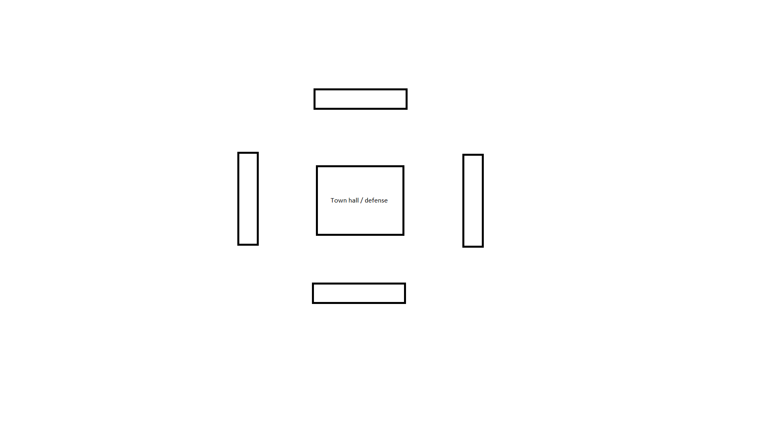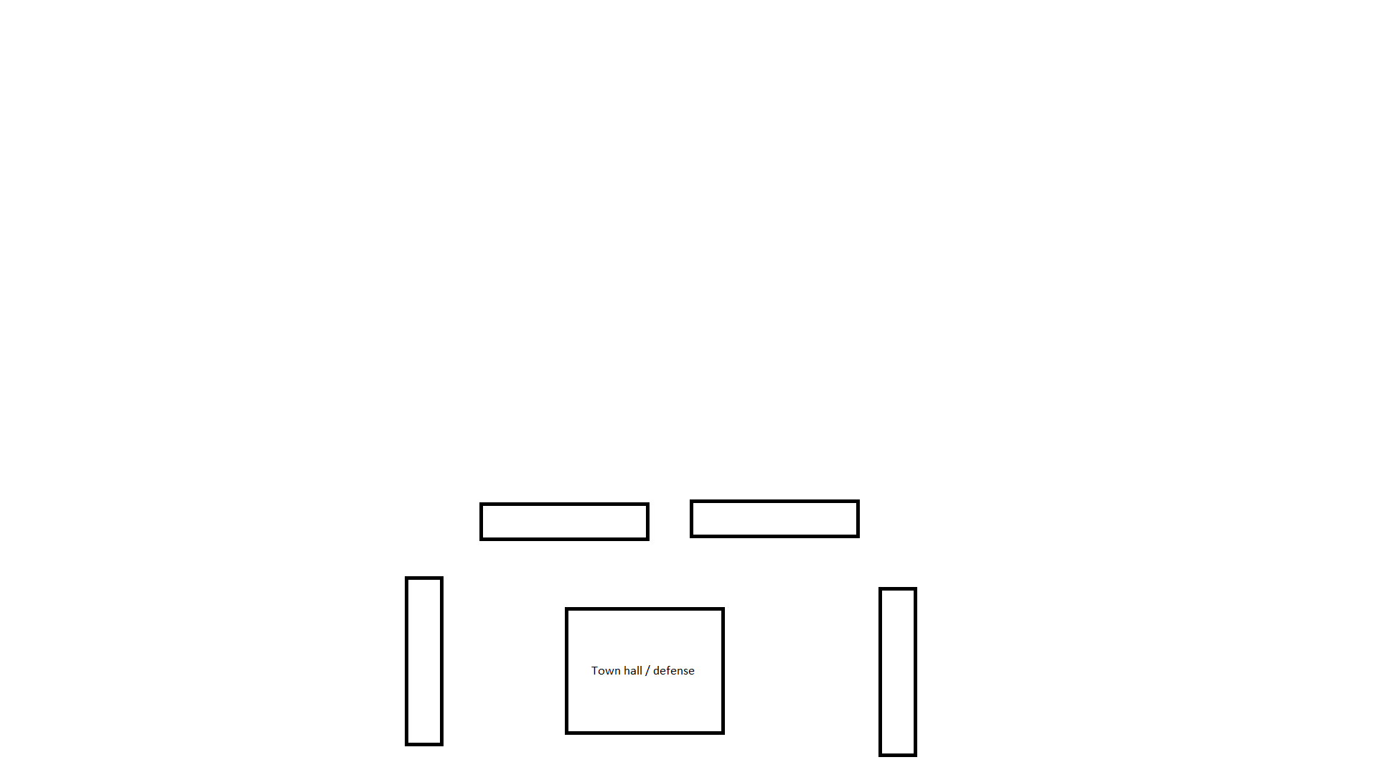

Game Components & Deliverables

Three levels of increasing complexity - hardcoded

Level generation *

Cards - Sci Fi theme

Online source for models - sci fi asset pack

1 Drone enemies

3 Wall cards?

1 Sniper turret

- infrequent fire and high damage - same model as next

1 Tank turret

- frequent fire and low damage - same model as above

1 AOE Turret

1 Special Turret:

* Some effect on enemy (stun/etc.)

Drone animation *

Cards:

* Physical Card Graphic
* Create Image Targets in Vuforia Database
* Link Image Targets to Models in Unity

Audio:

* Create Sound Effects
  + Background music
  + Turret sounds
  + Drone sounds
  + “Attacking” sounds
* Create Sound Manager Script
* Link Sounds

UI:

* Home Screen
  + Choose Level -> Proceed to Stage 1
  + Potential additions:
    - Sound settings*
    - High Scores*
    - Card stats*
    - Saved arrangements?
* Stage 1: Constructing Defense
  + Display what level this is
  + CONFIRM THAT BASE CARD IS PLACED
  + Play Button -> Proceed to Stage 2
  + Card slot indicators
  + Number of slots filled indicator
  + Card confirmation
    - Place
    - Remove
    - View stats?
* Stage 2: Enemies Attack
  + Stop Button -> Return to Stage 1
  + Health of building indicators*
* Stage 3: Results of Battle
  + Win or Lose?
  + If Win
    - Score*
    - Rewarded Points -> Upgrade structures
  + If Lose
    - Try Again -> Return to Stage 1

Game Development Structure

Managers:

* EnemyManager
* UpgradeManager
  + Killing enemies gives player money
* AudioManager
* SceneManager
* Placement Phase
* LevelManager
* OnFound
  + Check ID of object Prefab (so we can’t infinitely place the same one)
  + UI Button appears to let user “Place” Object
    - Target is de-parented from image
      * Moved to ground plane?
      * Can it remain just static?
* Playing Phase
  + User presses play button
  + Enemies spawn
  + Enemies tries to move to central point
  + Stops to attack any obstruction in the way
  + Game is over when enemies die OR reactor is destroyed
* Report Phase
  + Track structure damage
  + Track damage to enemies
  + Time

Initial Responsibility Distribution - Subject to Change

Development - Juri Kiin & Sam Levvy

* Game mechanics, level construction, game state, etc

Visuals - Kegan Sovay

* Target images, sci-fi aesthetic, overall branding, model location

Audio - Bennett Schoonerman

* Diegetic and non-diegetic sounds, possibly custom made

UI - Zoe Kniskern

* UI Screens, interactions